New Robust Ethernet Recorder BRICK SE

b-plus presents the brand new BRICK SE data logger for various industrial applications

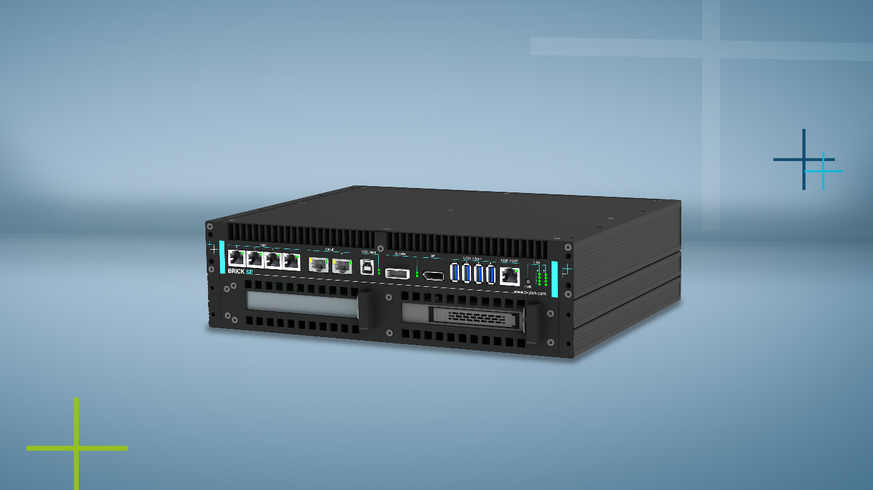

Product Picture: Ethernet Recorder BRICK SE

**Deggendorf, 23.07.2024 - The BRICK SE is a reliable solution for recording, processing and storage of data streams. Designed as a robust and cost-effective entry-level variant, it offers a simple removable storage concept and robust performance specifically tailored to the needs of industrial applications.**

Thanks to its extended temperature range of -25 °C to +70 °C and its durable components, the BRICK SE is ideal for a wide range of applications. Its exceptional robustness and mechanical stability make it the perfect choice for demanding industrial applications. In addition, the BRICK SE impresses with its compact form factor, which makes it a space-saving solution in any environment.

Another highlight of the BRICK SE is its variety of interfaces. With numerous Ethernet interfaces and USB ports, it offers maximum flexibility and numerous connection options. To meet individual requirements, it also offers an expansion slot that enables the integration of additional interfaces.

For maximum accuracy, the BRICK SE supports the XTSS Universal Time Synchronization Service, an integral part of the highly accurate and powerful timing concept from b-plus. This precise time synchronization can be optionally retrofitted to ensure reliable time stamping of all data.

With BRICK SE, users benefit from an open concept and ensure long-term investment security thanks to the high availability and compatibility of all components.

The Ethernet Logger BRICK SE is now available. For further information and contact to our experts, please visit the [product website](https://www.b-plus.com/en/portfolio/industrial-generic/ethernet-recorder-brick-se?mtm_campaign=2413&mtm_medium=PM).

CONTACT

Carina Franke

Product Marketing

carina.franke@b-plus.com

Simone Adam

Marketing Communications

simone.adam@b-plus.com

phone: +49 991 270302-0

[www.b-plus.com](https://www.b-plus.com/en?mtm_campaign=2107_MAX%20Insights&mtm_medium=PM_BRICK25)

Address:

b-plus technologies GmbH

Ulrichsberger Str. 17

94469 Deggendorf

Germany

ABOUT B-PLUS GROUP

The b-plus Group is with more than 230 employees an international leading development partner for advancing technologies in the fields of autonomous driving, driver assistance systems and the automation of mobile machines. With its development tools, automotive software and mobile automation divisions, it offers its customers a wide range of measurement technology, software and hardware.

As a long-term partner, b-plus accompanies its customers from the identification of the problem to the implementation of the development solution and beyond. The teams at the Deggendorf, Regensburg, Cham and Lindau locations work hand in hand to provide comprehensive and holistic solutions.