b-plus introduces the next generation of High-Performance Data Storages

Deggendorf, June 06, 2023 - The new x8 STORAGE Gen4 E1.S is a removable mass storage device with impressive data transfer rates of 96 Gbit/s in combination with DATALynx ATX4 and 48 Gbit/s in combination with BRICK2. The device offers continuous write performance even under demanding conditions at ambient temperatures of up to 60°C. Regarding the capacity of the new storage unit, b-plus offers 30TB and 60TB versions available from the third quarter of 2023, and a 120TB version scheduled for release in 2024.

With encryption based on TCG Opal Rev 2.01, the x8 STORAGE guarantees the highest level of security when transferring data within the setup or test carrier. In addition, the device supports hot-plug and hot-swap for b-plus's BRICK2 and ATX4 systems, allowing drives to be easily swapped out as needed. This noticeably increases the flexibility, efficiency and performance of your system.

The x8 STORAGE features an integrated RAID controller, PCIe 4.0 design, and eight NVMe enterprise SSDs, all of which work seamlessly together to deliver lightning-fast data transfer speeds. It also features a USB-C data interface and 12 V input for standalone operation and easy access.

For more information and to get in touch, visit b-plus.com.
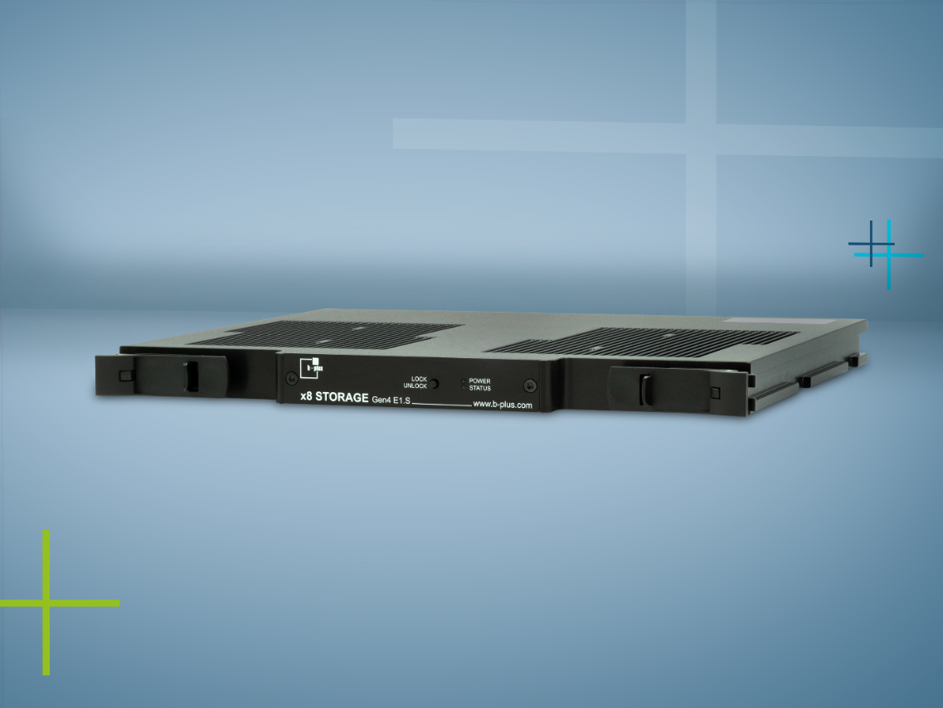
Picture: x8 STORAGE Gen4 E1.S from b-plus

CONTACT

Carina Franke
Product Marketing
carina.franke@b-plus.com

Simone Adam
Marketing Communications
simone.adam@b-plus.com

phone: +49 991 270302-0
www.b-plus.com

Address:
b-plus technologies GmbH
Ulrichsberger Str. 17
94469 Deggendorf
Germany

ABOUT B-PLUS GROUP
The b-plus Group is with more than 230 employees an international leading development partner for advancing technologies in the fields of autonomous driving, driver assistance systems and the automation of mobile machines. With its development tools, automotive software and mobile automation divisions, it offers its customers a wide range of measurement technology, software and hardware.

As a long-term partner, b-plus accompanies its customers from the identification of the problem to the implementation of the development solution and beyond. The teams at the Deggendorf, Regensburg, Cham and Lindau locations work hand in hand to provide comprehensive and holistic solutions.

