Experiencing the Mobility of the Future
In cooperation with b-plus Arnold NextG realizes innovative drive-by-wire technologies

Deggendorf / Aichelau, July 18, 2023 – Bringing the mobility of the future onto the road with the latest technologies: that is the shared goal of b-plus and Arnold NextG and b-plus. On July 16th, b-plus and other partners introduced themselves to the public at the Open House event in Aichelau, showcasing test vehicles and a joint car-to-car demonstration.

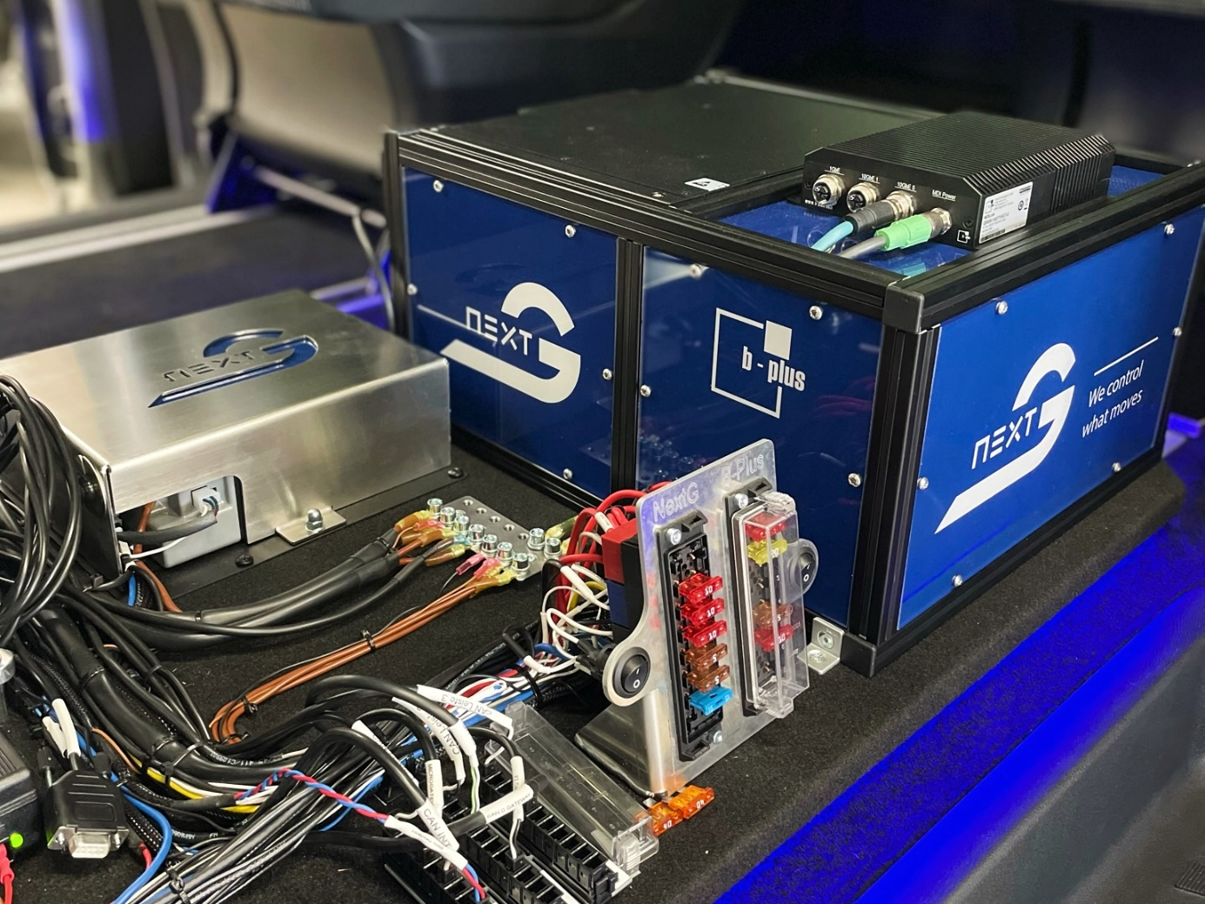
b-plus and Arnold NextG and leverage coordinated interfaces and complementary long-standing engineering know-how to drive joint projects forward. Source: Arnold NextG. Download

b-plus and Arnold NextG leverage their perfectly coordinated interfaces and complementary long-standing engineering know-how to drive joint projects in the development of ECU base software, cloud integration, and comprehensive data recording from various sources such as sensors (camera, lidar, radar) and ECU signals.

As part of the Open House event on July 16, 2023, in Aichelau, the strong partners showcased hands-on experiences of the mobility of the future: multiple redundant drive-by-wire systems with all interfaces for autonomous driving. Demonstrations included the integrated measurement solutions in Arnold NextG's demo vehicle, b-plus' test vehicle for system validation, and a joint car-to-car demonstration by Arnold NextG.

As a corporate group, b-plus has positioned itself as a development partner for the automotive industry over the past 27 years, focusing on mobile automation, basic software development for control units, and the manufacturing of development and measurement tools for ADAS systems and automated driving. Starting as an engineering office in Deggendorf, Lower Bavaria, b-plus is now internationally connected and employs around 240 experts in software and hardware components, as well as overall concept solutions for the validation and verification of automated driving systems on the road and in "off-highway" applications.

Arnold NextG offers a customizable drive-by-wire technology as the foundation for safe autonomous driving, specializing in the development of multiple redundant drive-by-wire systems with all interfaces for autonomous driving. As an independent advanced developer, incubator, and system supplier, Arnold NextG has the agility to realize highly individual requirements and complex projects. With over 20 years of experience in road-legal drive-by-wire technology, the company possesses unique expertise in developing retrofit solutions for all by-wire applications.

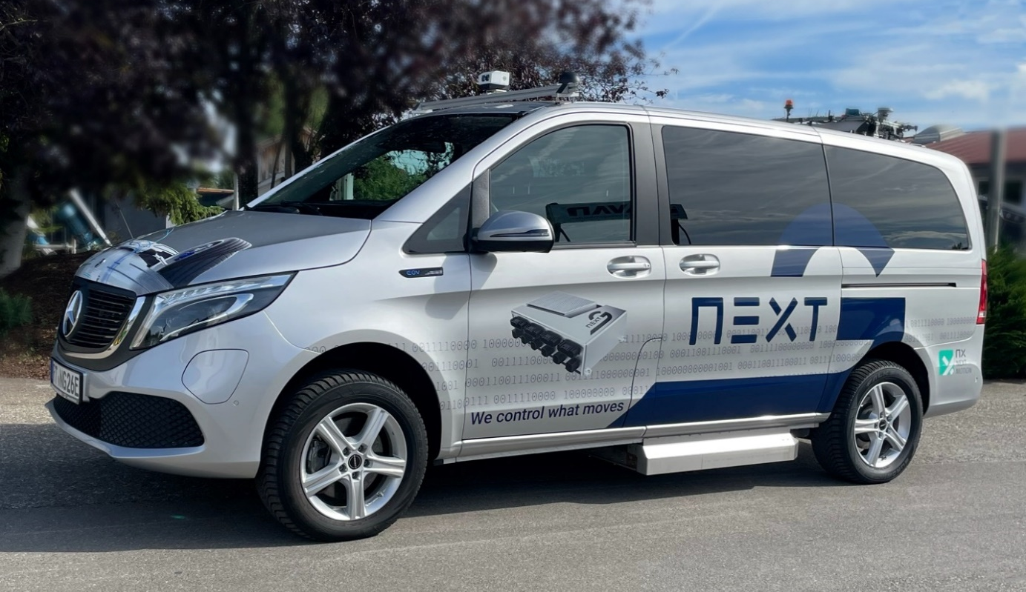
As part of the Open House event on July 16, 2023, in Aichelau, the strong partners showcased hands-on experiences of the mobility of the future. Source: Arnold NextG. Download

Further information about b-plus and Arnold NextG is available on the websites at b-plus.com and arnoldnextg.de.

CONTACTS

Simone Adam
Marketing Communications b-plus group
simone.adam@b-plus.com
phone: +49 991 270302-0
www.b-plus.com

Jochen Knecht
Head of Communication, Arnold NextG GmbH
jochen.knecht@arnoldnextg.de
phone: +49 151 1881 77 62

ABOUT B-PLUS GROUP
The b-plus Group is with more than 240 employees an international leading development partner for advancing technologies in the fields of autonomous driving, driver assistance systems and the automation of mobile machines. With its development tools, automotive software and mobile automation divisions, it offers its customers a wide range of measurement technology, software and hardware.

As a long-term partner, b-plus accompanies its customers from the identification of the problem to the implementation of the development solution and beyond. The teams at the Deggendorf, Regensburg, Cham and Lindau locations work hand in hand to provide comprehensive and holistic solutions.

ABOUT ARNOLD NEXTG GMBH
Arnold NextG realizes the Safety by Wire®-Technology of tomorrow. We offer the globally unique and multi-redundant central control unit NX NextMotion, which complies with the latest regulations and enables fail-safe and individual implementation in all application areas. As an independent advance developer, incubator and system supplier, Arnold NextG takes care of planning and implementation - from vision to road approval.

