Maximum flexibility for industrial engines with the b-plus EngineMonitor displays

Deggendorf, March 30, 2023 - With the EngineMonitor display devices, the development expert for mobile automation b-plus offers expansion tools especially for the use in industrial engines with CAN J1939 interface. They enable the user to retrieve information from mobile machines and communicate commands directly.

Thanks to their robust housings and protection level, the devices can be operated not only directly in the cab, but also in the outdoor area of mobile machines. The compact devices offer maximum flexibility for the user. Because of various device versions the product range covers diverse use cases and customer needs. Customer-specific adaptations can be done by the experienced team at b-plus.

Due to the standardized J1939 communication as well as some engine manufacturer specific extensions, the b-plus Engine Monitor products are designed to meet the demands of the most common industrial engines like CAT®, Cummins®, DEUTZ®, FPT/Iveco®, HATZ Diesel®, Perkins®, MAN®, Scania®, Volvo Penta®, etc.

The product portfolio comprises three device types.
- EngineMonitorMini as a basic version with fixed display values of selected engine data.
- EngineMonitorPlus with flexible display values as well as operating options for speed and exhaust gas aftertreatment of an industrial engine - parameterizable directly on the display.
- EngineMonitorMaxi with flexible display values and operating options as well as additional inputs and outputs for non-CAN-capable sensors/actuators - parameterizable via the PC tool.

EngineMonitorMini
The EngineMonitorMini is the basis version of the product line and offers a clear overview of common messages according to the SAE J1939 standard. On three different pages numerous CAN messages transmitted from the engine are displayed, such as engine speed, engine oil pressure, battery voltage, etc. The integrated fault diagnosis on page four allows the discovery of possible errors of the engine, e.g. wire break of the speed sensor etc.
Convetional analog or digital display instruments can be replaced or retrofitted economically with the EngineMonitorMini. Customers can choose between three basic units with different display sizes and mounting dimensions as well as frosted and clear glass.
The EngineMonitorMini provides simple navigation via backlit navigation keys with tactile feedback.

EngineMonitorPlus
The EngineMonitorPlus is based on the same display types as the EngineMonitorMini, but is fully configurable. Multilanguage , maintenance reminder, an easy configuration directly via the display without PC and an intuitive operating concept are only some features of the EngineMonitorPlus. The motor data are displayed clearly on three pages, the user can choose between several layout options. In the „one quadrant layout“ different values can be switched via buttons or time based. In the „multi quadrant layout“ four values can be shown simultaneous. Furthermore the presentation of the information in row view is available.
The EngineMonitorPlus also has an error and maintenance page. On this page the error signals sent by the DM1 message and the customer specific maintenance messages are shown. If an error is active the LED on the bottom right corner of the display is blinking red. For warning or maintenance the LED is flashing orange. The error display can show up to seven errors simultaneously.
On a parameterizable control signal page, messages from the EngineMonitorPlus can be sent to the industrial engine. It allows the user to directly manage parameters such as speed control (TSC1), SCR/DPF regeneration force and inhibit as well as motor start/stop. The display therefore is ideally equipped to meet the requirements of TIER4 final / EU STAGE V.

EngineMonitorMaxi
The EngineMonitorMaxi also is a fully configurable display for industrial engines and an extremely powerful and versatile product, suited to a large number of different application environments. The basic device is the E050 from DSE. The display is fully configurable using a licence-free PC software, which enables users an individual parameter setting for all pages and CAN signals.
The display icons are adjustable for each signal. Customers can add their company branding to the displays start-up screen and select from a light and dark background when the module is in use.
The EngineMonitorMaxi has four additional configurable inputs (digital, current, voltage, resistance, e.g. for the connection of analog fill level sensors) as well as three outputs for external relays, LEDs and audible buzzer.

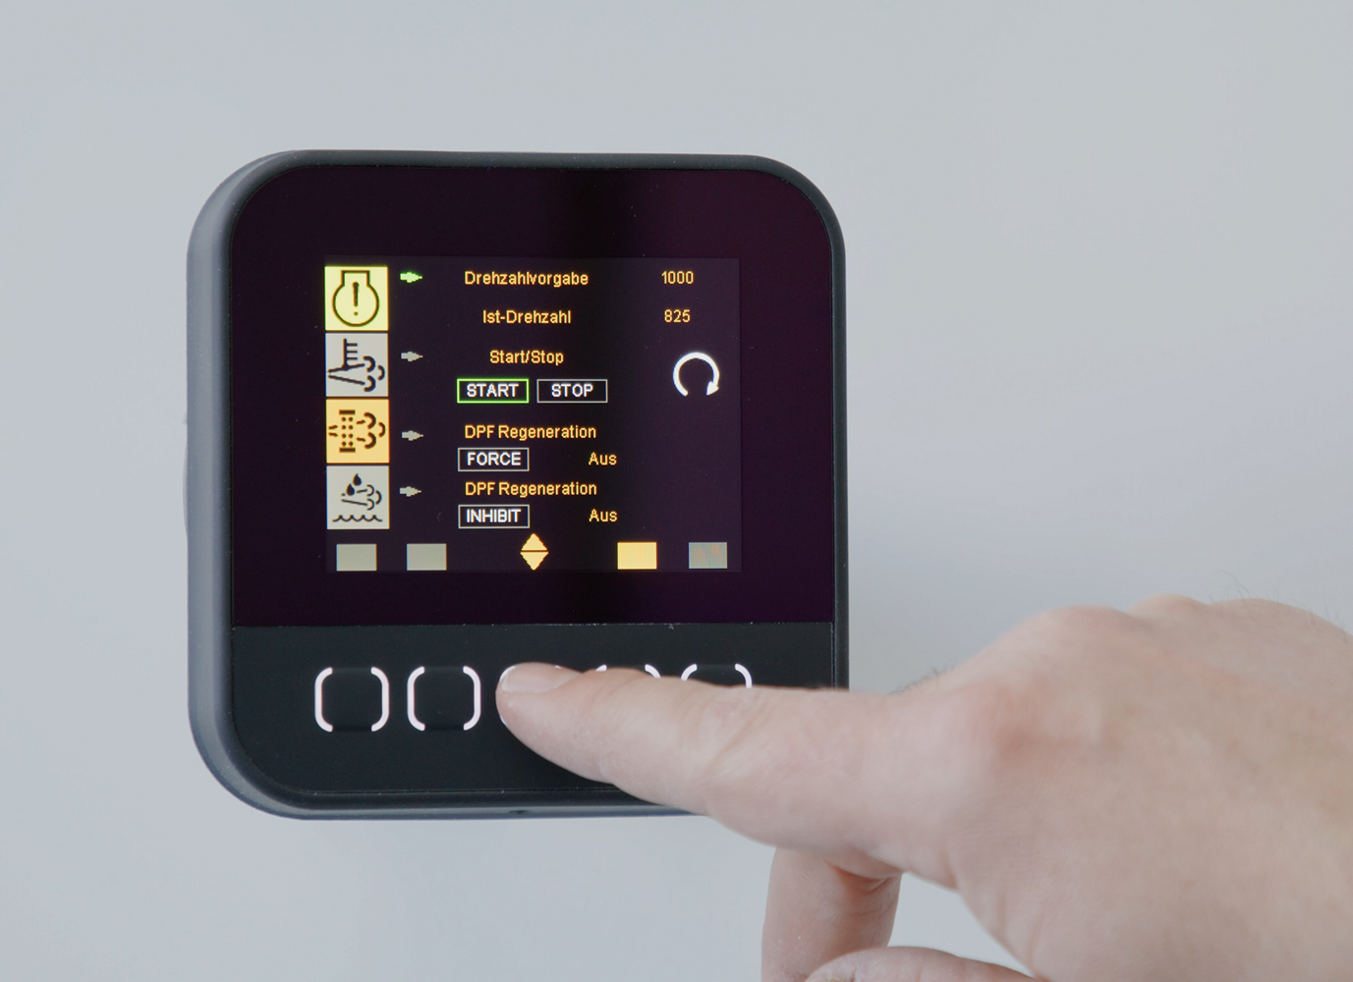
Picture: EngineMonitorPlus with the view of the speed specification

More information about b-plus at b-plus.com
CONTACT

Simone Adam
Marketing Communications
simone.adam@b-plus.com

phone: +49 991 270302-0
b-plus.com

Address:
b-plus mobile control GmbH
Ulrichsberger Str. 17
94469 Deggendorf
Germany

ABOUT B-PLUS GROUP
The b-plus Group is with more than 230 employees an international leading development partner for advancing technologies in the fields of autonomous driving, driver assistance systems and the automation of mobile machines. With its development tools, automotive software and mobile automation divisions, it offers its customers a wide range of measurement technology, software and hardware.

As a long-term partner, b-plus accompanies its customers from the identification of the problem to the implementation of the development solution and beyond. The teams at the Deggendorf, Regensburg, Cham and Lindau locations work hand in hand to provide comprehensive and holistic solutions.

